
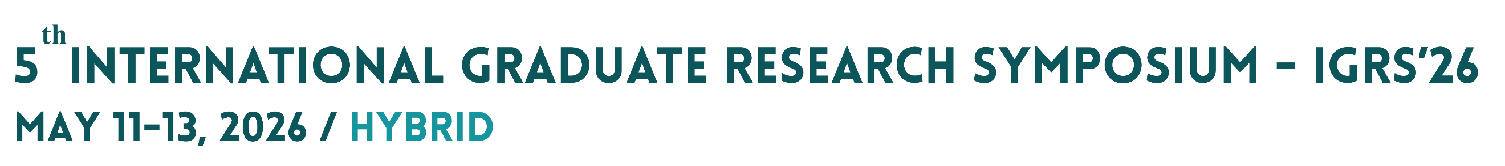
2 cm
2,5 cm
2,5 cm
13 cm
PAPER TITLE (Times New Roman, 65 pt, bold, centered)
Presenting Author Name¹ , Other Authors ² (40 pt, bold)
¹ Institute, Department, Program, Country (35 pt, italic)
² Institute, Department, Program, Country (35 pt, italic)

A0
84,1 X 118,9 cm

2 cm

Poster Format

- Posters should be prepared vertically and only 1 page. Poster size should be A0 paper.
- The font style should be Times New Roman.
- Poster title should be written in uppercase letters, 65 pt, bold, and centered.
- There should be 2,5 cm space left and right, and 2 cm space from the bottom. The logo line should be 15 cm as shown in the figure above. Images and tables included in the abstract can be added.
- The author's name(s) should be written in bold and 40 pt.
- The author's address(es) should be written in 35 pt italics.
- The name of the researcher presenting the poster should be underlined.
- All headings within the text (Abstract, Introduction, Materials and Methods, Results and Discussion, Conclusion, etc.) should be written in uppercase, bold, and between 35-40 pt.
- The poster text should be written in 35-40 pt font. Do not use italics in the text; you may use bold for important keywords.
- The text should be justified.
- Figure captions and table titles should be between 20 pt and 25 pt.
- Line spacing can be left for readability.
- The text of the sources in the bibliography should be written in APA 7 format using 25-30 pt non-bold font.
- Tables, images and equations should be numbered and referenced in the text.
- The presentation of information on the poster should emphasize visuals (graphs, charts, drawings, pictures, photographs). All graphs, tables, and figures on the poster must be of readable size and resolution.
- Use a simple, single colour for the background of the poster and please select a small palette of colours—perhaps three or four for designing poster (using these colours repeatedly throughout the project makes the work look more cohesive and ultimately more professional).

- Please keep the text as short and simple as possible and remove all non-essential information that will only clutter up the poster. Just as you would when designing a set of slides to use in an oral presentation, you should think about using keywords and phrases and bullet-points instead of whole sentences and paragraphs
- Printing paper type should be 170 gr coated paper and 300 dpi. Files must be uploaded in PDF format and the file size must be a maximum of ..... Mb. Please upload your poster to the e-poster section of the ARCADIAS interface. After your poster has undergone format checks, you will be contacted; revisions may be requested if necessary.
- If your poster is approved, you need to bring your printed poster to the ITU Süleyman Demirel Arts and Conference Center in Ayazaga Campus. Please follow the announcements for the presentation schedule and other informations.

